BDDA – 2 Project 1: **Database Management using MySQL & SQL**

**Submitted by: Arushi Khanna, Domain: HR – Employee Database on Amazon**

Database Images (before CRUD Operations and put Dummy Data)

Location

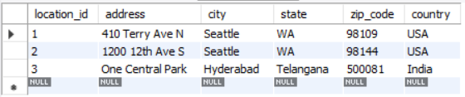

Department

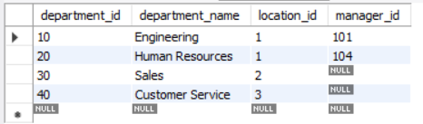

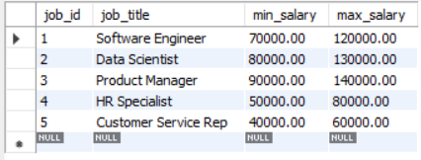

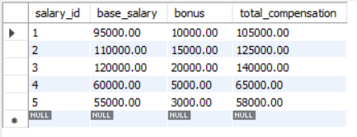

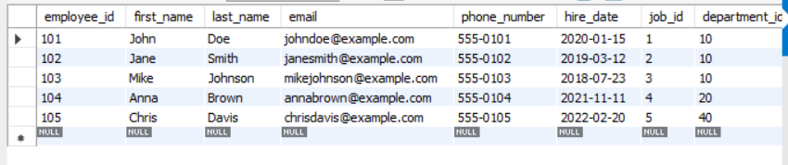

Before CRUD Operations:

CREATE DATABASE amazon_employee_db;

USE amazon_employee_db;

-- Table: Locations

CREATE TABLE Locations (

location_id INT PRIMARY KEY,

address VARCHAR(255),

city VARCHAR(100),

state VARCHAR(100),

zip_code VARCHAR(20),

country VARCHAR(100)

);

-- Table: Departments

CREATE TABLE Departments (

department_id INT PRIMARY KEY,

department_name VARCHAR(100),

location_id INT,

manager_id INT,

FOREIGN KEY (location_id) REFERENCES Locations(location_id),

FOREIGN KEY (manager_id) REFERENCES Employees(employee_id) -- Self-reference for manager

);

-- Table: Jobs

CREATE TABLE Jobs (

job_id INT PRIMARY KEY,

job_title VARCHAR(100),

min_salary DECIMAL(10, 2),

max_salary DECIMAL(10, 2)

);

-- Table: Salaries

CREATE TABLE Salaries (

salary_id INT PRIMARY KEY,

base_salary DECIMAL(10, 2),

bonus DECIMAL(10, 2),

total_compensation DECIMAL(10, 2) AS (base_salary + bonus) STORED

);

-- Table: Employees

CREATE TABLE Employees (

employee_id INT PRIMARY KEY,

first_name VARCHAR(50),

last_name VARCHAR(50),

email VARCHAR(100) UNIQUE,

phone_number VARCHAR(20),

hire_date DATE,

job_id INT,

department_id INT,

manager_id INT,

salary_id INT,

FOREIGN KEY (job_id) REFERENCES Jobs(job_id),

FOREIGN KEY (department_id) REFERENCES Departments(department_id),

FOREIGN KEY (manager_id) REFERENCES Employees(employee_id), -- Self-reference for manager

FOREIGN KEY (salary_id) REFERENCES Salaries(salary_id)

);

DROP DATABASE amazon_employee_db;

CREATE DATABASE amazon_employee_db;

USE amazon_employee_db;

-- Table: Locations

CREATE TABLE Locations (

location_id INT PRIMARY KEY,

address VARCHAR(255),

city VARCHAR(100),

state VARCHAR(100),

zip_code VARCHAR(20),

country VARCHAR(100)

);

-- Table: Departments (initial creation without manager_id FK)

CREATE TABLE Departments (

department_id INT PRIMARY KEY,

department_name VARCHAR(100),

location_id INT,

FOREIGN KEY (location_id) REFERENCES Locations(location_id)

);

-- Table: Jobs

CREATE TABLE Jobs (

job_id INT PRIMARY KEY,

job_title VARCHAR(100),

min_salary DECIMAL(10, 2),

max_salary DECIMAL(10, 2)

);

-- Table: Salaries

CREATE TABLE Salaries (

salary_id INT PRIMARY KEY,

base_salary DECIMAL(10, 2),

bonus DECIMAL(10, 2),

total_compensation DECIMAL(10, 2) AS (base_salary + bonus) STORED

);

-- Table: Employees (initial creation without foreign key constraints)

CREATE TABLE Employees (

employee_id INT PRIMARY KEY,

first_name VARCHAR(50),

last_name VARCHAR(50),

email VARCHAR(100) UNIQUE,

phone_number VARCHAR(20),

hire_date DATE,

job_id INT,

department_id INT,

manager_id INT,

salary_id INT

);

-- Add foreign key constraints for Employees after all tables have been created

ALTER TABLE Employees

ADD FOREIGN KEY (job_id) REFERENCES Jobs(job_id),

ADD FOREIGN KEY (department_id) REFERENCES Departments(department_id),

ADD FOREIGN KEY (manager_id) REFERENCES Employees(employee_id), -- Self-reference for manager

ADD FOREIGN KEY (salary_id) REFERENCES Salaries(salary_id);

-- Add the manager_id foreign key to Departments after Employees table is created

ALTER TABLE Departments

ADD manager_id INT,

ADD FOREIGN KEY (manager_id) REFERENCES Employees(employee_id);

-- Insert dummy data into Locations

INSERT INTO Locations (location_id, address, city, state, zip_code, country)

VALUES

(1, '410 Terry Ave N', 'Seattle', 'WA', '98109', 'USA'),

(2, '1200 12th Ave S', 'Seattle', 'WA', '98144', 'USA'),

(3, 'One Central Park', 'Hyderabad', 'Telangana', '500081', 'India');

-- Insert dummy data into Departments

INSERT INTO Departments (department_id, department_name, location_id)

VALUES

(10, 'Engineering', 1),

(20, 'Human Resources', 1),

(30, 'Sales', 2),

(40, 'Customer Service', 3);

-- Insert dummy data into Jobs

INSERT INTO Jobs (job_id, job_title, min_salary, max_salary)

VALUES

(1, 'Software Engineer', 70000, 120000),

(2, 'Data Scientist', 80000, 130000),

(3, 'Product Manager', 90000, 140000),

(4, 'HR Specialist', 50000, 80000),

(5, 'Customer Service Rep', 40000, 60000);

-- Insert dummy data into Salaries

INSERT INTO Salaries (salary_id, base_salary, bonus)

VALUES

(1, 95000, 10000),

(2, 110000, 15000),

(3, 120000, 20000),

(4, 60000, 5000),

(5, 55000, 3000);

-- Insert dummy data into Employees

INSERT INTO Employees (employee_id, first_name, last_name, email, phone_number, hire_date, job_id, department_id, manager_id, salary_id)

VALUES

(101, 'John', 'Doe', 'johndoe@example.com', '555-0101', '2020-01-15', 1, 10, NULL, 1),

(102, 'Jane', 'Smith', 'janesmith@example.com', '555-0102', '2019-03-12', 2, 10, 101, 2),

(103, 'Mike', 'Johnson', 'mikejohnson@example.com', '555-0103', '2018-07-23', 3, 10, 101, 3),

(104, 'Anna', 'Brown', 'annabrown@example.com', '555-0104', '2021-11-11', 4, 20, NULL, 4),

(105, 'Chris', 'Davis', 'chrisdavis@example.com', '555-0105', '2022-02-20', 5, 40, NULL, 5);

-- Update Departments to assign manager_id for each department where applicable

UPDATE Departments SET manager_id = 101 WHERE department_id = 10;

UPDATE Departments SET manager_id = 104 WHERE department_id = 20;

SELECT * FROM Locations;

SELECT * FROM Departments;

SELECT * FROM Jobs;

SELECT * FROM Salaries;

SELECT * FROM Employees;

After CRUD Operations:

CREATE

INSERT INTO Employees (employee_id, first_name, last_name, email, phone_number, hire_date, job_id, department_id, manager_id, salary_id)

VALUES (106, 'Emily', 'Clark', 'emilyclark@example.com', '555-0106', '2023-05-14', 1, 10, 101, 1);

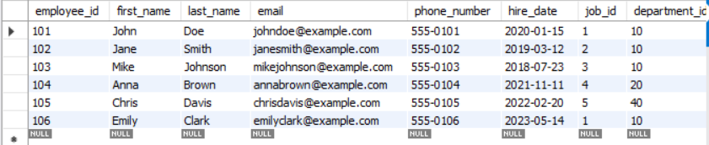

READ

SELECT * FROM Employees;

-- Select specific columns

SELECT first_name, last_name, email FROM Employees;

-- Select employees with specific criteria (e.g., from Engineering department)

SELECT * FROM Employees WHERE department_id = 10;

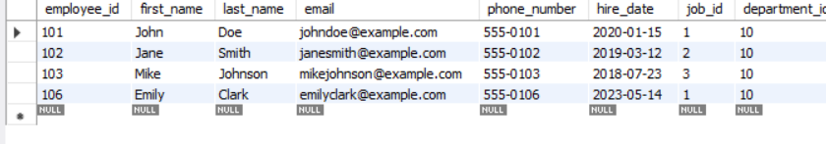

UPDATE

UPDATE Employees SET job_id = 2, salary_id = 2 WHERE employee_id = 106; -- Increase the base salary in Salaries table for a specific employee's salary entry UPDATE Salaries SET base_salary = base_salary + 5000 WHERE salary_id = 1;

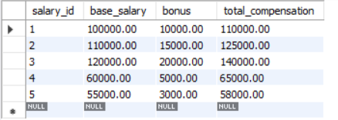

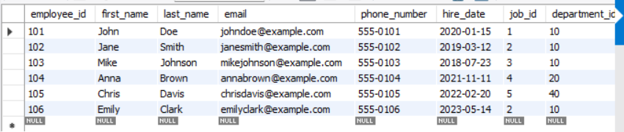

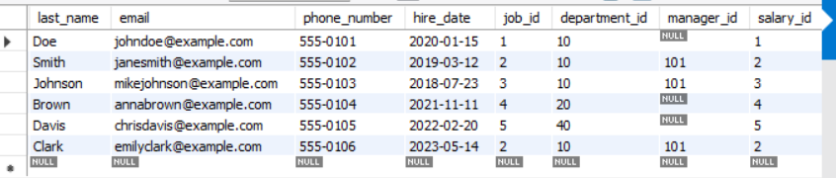

DELETE

DELETE FROM Employees WHERE employee_id = 106; -- Delete all employees from a specific department (e.g., department_id = 20) DELETE FROM Employees WHERE department_id = 20;

